|  |  |
| --- | --- |
|  | **icenter.media** |
|  |  |
|  | Analog clock configuration |
|  |  |
|  |  |
|  |  |
|  | Guideline |
|  |  |
|  | Version: 0.2 |
|  | State: Draft |
|  | Classification: Internal use only |
|  | Author: EPT |
|  | Creation date: 2014-11-14 |
|  | Repository: /Main/Center/Media/Documents/Analog clock configuration.docx |
|  | Gorba AG  Sandackerstrasse  9245 Oberbüren  Switzerland |

**Table of contents**

1 Introduction 4

2 Configuration 4

2.1 General 4

2.2 Properties of a hand 4

3 Step by step example 5

3.1 Specification 5

3.2 Add the background picture with the font face 5

3.3 Create an analog clock element and resize it, so that the selection border fits the clock face 6

3.4 Add the hand media files 6

3.5 Set the properties of the hands in the property grid 7

3.6 Do fine tuning 7

3.7 Result 8

**Modification management**

|  |  |  |  |  |  |
| --- | --- | --- | --- | --- | --- |
| **Version** | **Date** | **Name** | **Dept.** | **Modifications** | **State** |
| 0.1 | 14.11.2014 | EPT | SW Dev. | First version | Draft |
| 0.2 | 17.11.2014 | EPT | SW Dev. | * Clarified widths and heights * Added some more comments in the figures | Draft |

**Review**

|  |  |  |  |  |
| --- | --- | --- | --- | --- |
| **Version** | **Date** | **Name** | **Dept.** | **Remarks** |
| 0.1 | 17.11.2014 | AMR | PO | Different widths and heights not clear |
|  |  |  |  |  |
|  |  |  |  |  |
|  |  |  |  |  |

**Release**

|  |  |  |  |  |
| --- | --- | --- | --- | --- |
| **Version** | **Date** | **Name** | **Dept.** | **Remarks** |
|  |  |  |  |  |
|  |  |  |  |  |
|  |  |  |  |  |
|  |  |  |  |  |

# Introduction

This document describes how to configure the hands of an analog clock.

# Configuration

## General

* Always round up because a pixel can’t have a fragment  
  E.g. 5 / 2 = 3
* The point of origin for the hands is the upper left corner of the clock element.

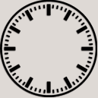

**(0,0)**

ClockWidth

ClockHeight

Figure - Clock element dimensions

## Properties of a hand

The default hand properties are set for a clock with Width = 128 and Height = 128.

The properties of a hand must always be set for 12 o’clock. It is also good to have an uneven width. Like that we have a pixel perfect center.

**Attention: The width and height of the hands must always be the real width and height of the picture file!**

(0,0)

Width

Center Y

Center X

Height



(0,0)

X



Y

Hand properties related to upper left corner of the hand

Hand properties related to clock element

Figure 2 - Hand measurements

The X and Y coordinates of a hand are calculated as followed:

* X = (ClockWidth/2) – Center X
* Y = (ClockHeight/2) – Center Y

# Step by step example

## Specification

**Clock face:**

* Width = 320
* Height = 320

**Hour hand:**

* Filename = Hour5x100.png
* Width = 5
* Height = 100
* Rotation should be 10 pixels inside the hand

**Minute hand:**

* Filename = Minute3x140
* Width = 3
* Height = 140
* Rotation should be 15 pixels inside the hand

**Seconds hand:**

* Not visible

## Add the background picture with the font face

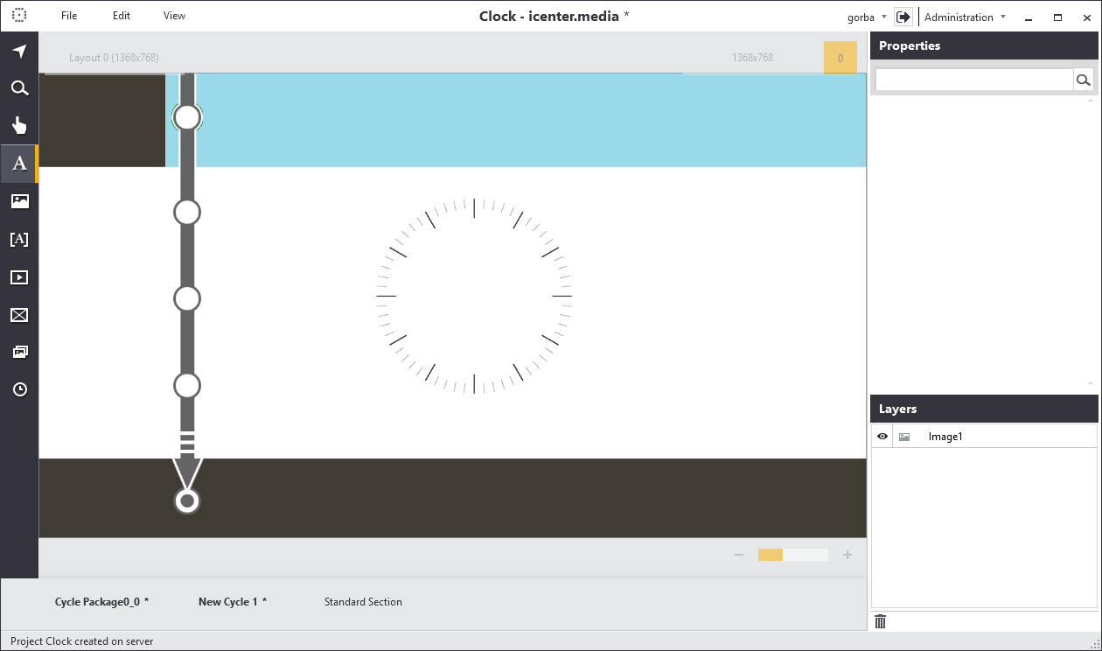

Figure 3 - Background with font face

## Create an analog clock element and resize it, so that the selection border fits the clock face

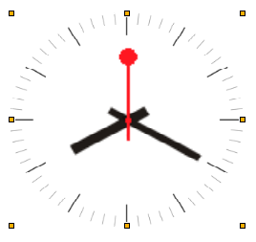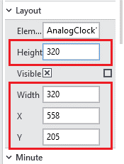

Figure 4 - Resize clock element

## Add the hand media files

You only need to do this step if the hands differ from the default ones added to the project.

For our example we have two hands, Hour5x100.png and Minute3x140.png

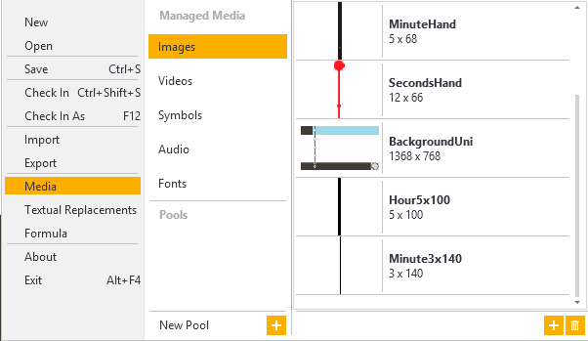

Figure - Add hand files

## Set the properties of the hands in the property grid

The hand values were calculated as followed:

* Height = Height of the picture file
* Width = Width of the picture file
* Center X = Width / 2 (round up)
* Center Y = Height – 10 pixel
* X = (ClockWidth / 2) – Center X
* Y = (ClockHeight / 2) – Center Y

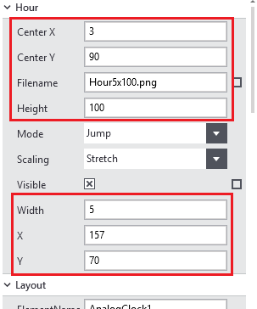 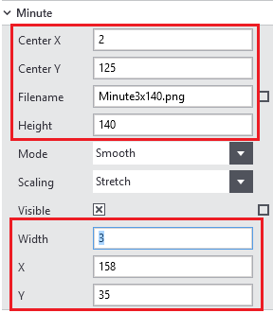

Figure 6 – Hour and minute hand properties

Unset the seconds hand Visible property to hide it.

## Do fine tuning

For testing it is better to set the Mode property to Jump. After that open the simulation window.

Test the hour hand position at the following hours (change the system time) and change the X and Y properties if needed:

12 h

03 h

06 h

09 h

Test the minute hand position at the 4 times (change the system time):

0 min

15 min

30 min

45 min

## Result

